CONFIDERATION OF SAHODAYA COMPLEX

MODEL EXAMINATION 2019-20

Marking Scheme

SET-1

Class XII BIOLOGY (044) MARKS: 70

SECTION A

- Which of the following ecosystem is most productive in terms of net primary production?
- Desert
- Tropical Rain Forest
- Oceans
- Estuaries

b) Tropical Rain Forest
(1)

OR
The extinction of passenger’s pigeon was due to
- Increased number of predatory birds
- Over exploitation by human
- Non availability of food
- Co-extinction

- Over exploitation by human
(1)

- Total amount of Adenine in double stranded DNA is 45%. The amount of guanine in the DNA would be
- 5%
- 55%
- 45%
- 10%

- 5 %
(1)
OR
In a DNA strand the nucleotides are linked together by
- Peptide bonds
- Hydrogen bonds
- Glycosidic bonds
- Phospho diester bonds

d) Phospho diester linkage
(1)
- The stimulant cocaine is obtained from
- Rauwolfia
- Erythroxylon
- Papaver
- Cannabis

- Erythroxylon
(1)

- Given below are a few statements related to external fertilization. Choose the correct statements
- The male and female gametes are formed simultaneously
- Only a few gametes are released in to the medium
- Water is the medium in a majority of organisms exhibiting external fertilization
- Offspring as a result of external fertilization have better chance of survival than those formed inside an organism

- iii & iv
- i & iii
- ii & iv
- i & iv
b) i & iii
(1)
- For the MN blood group system, the frequencies of M & N alleles are 0.7 and 0.3 respectively. The expected frequency of MN blood group bearing organisms is likely to be
- 42%
- 49%
- 24%
- 58%

a) 42%
(1)

SECTION B

- A herd of cattle showing reduced fertility and productivity. Provide one reason and one suggestion to overcome this problem.

Reason: Inbreeding depression.
Suggestion: Should be mated with unrelated superior cattle of the same breed – outcrossing.
(1 X 2 = 2)

OR

How did plant breeding technique help North Indian farmers to develop Sugar cane with desirable characters?

Saccharum offinarum had thick stem and higher sugar content but did not grow in North India. But it can live only in Tropical/South India.
(0.5)
Saccharum barberi grown in North India had poor sugar content and yield.
(0.5)
These two species were successfully crossed to get an inter-specific hybrid. It has desirable characters of both the plants, i.e., thick stem, high sugar content and can grow in North India/cross with characters.
(0.5 X 2 =1)

- How did a citizen group called “Friends of Arcata Marsh”, Arcata, California, USA help to improve water quality of marsh land using integrated waste water treatment? Explain four steps.

- Water is treated by conventional methods/ sedimentation/filtration/chlorination.
- Water flows to six connected marshes.
- Water in the marshes is seeded with appropriate plants/algae/fungi/bacteria.
- This helps to neutralize the pollutants/assimilate the pollutants/remove heavy metals.
(0.5 X 4 =2)

- A mature embryosac in flowering plant may possess seven cells, but eight nuclei. Explain with the help of a diagram.

Megaspore (N) divides three times producing eight nuclei – four at chalazal region and four at micropylar region.
(0.5)
From each group, one nucleus moves towards the centre. So, three cells at chalaza antipodals; three at micropylar region egg apparatus. 3 + 3 cells and middle central cell with 2 nuclei.
(0.5)
For figure, refer NCERT Textbook, Figure 2.8, c (page 26).
(1)
(0.5 X 2 + 1 = 2)

- How do Mycorrhizae help the plants to grow better?

Association of roots of plants with fungi – absorbs P from soil and passes it to plants – resistant to root borne diseases – tolerance to salinity and drought.
(0.5 X 4 = 2)

- If a father and son, both are defective in red-green colour vision, is it likely that the son inherited the trait from his father. Comment.

Red-green colour blindness is a sex-linked recessive character.
Mother transfers this character to her son. The mother gets this from her father, i.e., father to grandson through his daughter – crisscross.
(1)
Recessive gene containing X chromosome of father is given to his daughters only. So, the son inherited the trait not from his father, but from the carrier, mother – Or, cross can be shown.
(1)
(1+1 = 2)

- In Pea tallness is dominant over dwarfness and violet colour of flower is dominant over the white colour. When a tall plant bearing violet flowers was pollinated with dwarf plant bearing white flowers, the different phenotypic groups were obtained in the progeny in numbers mentioned against them
Tall Violet 138
Tall White 135
Dwarf Violet 136
Dwarf White 132
Mention the genotype of the two parents and the 4 offspring types.
The result shows four types of offspring with almost similar in number with ratio 1:1:1:1, i.e., a result of dihybrid test cross. So, the genotype of parents is dihybrid with its homozygous recessive parents: TtRr X ttrr.
(1)
Genotype of offspring:
TtRr Tall Violet 1, Ttrr Tall White 1, ttRr Dwarf Violet 1, ttrr Dwarf White 1.
(1)
(1+1=2)

- Besides better aeration and mixing properties, what other advantages do stirred tank bio reactors have over shake flasks?

Stirred-tank bio-reactors have agitator and oxygen delivery system. In addition to these, they have the following.
- A foam control system
- A temperature control system
- A pH control system
- A sampling port to withdraw the small volume of the culture periodically.
(0.5 X 4 = 2)

SECTION C

- A number of passengers were severely burnt beyond recognition during a train accident. Name and describe a modern technique that can help hand over the dead to their relatives.

The technique is called DNA finger printing.
(0.5)
The following steps are to be taken.
- Isolation of DNA and its digestion by restriction endonucleases.
- Separation of DNA fragments by gel electrophoresis.
- Transferring separated DNA molecule to synthetic nitrocellulose or Nylon.
- Hybridization of these DNA with UNTR probes.
- Detection of hybridized DNA by auto-radiography.
- Matching the banding pattern to obtain with that of relatives.
(Any five points: 5 X 0.5 = 2.5)
(2.5 + 0.5 = 3)

- Describe how do ‘Flocs’ and ‘Activated Sludge’ help in Sewage treatment.

Flocs: Aerobic microbes that consumes a major part of organic matter in the effluent.
(1.5)
Activated Sludge: A small part of it is used as an inoculum and pumped back to the aeration tank. Remaining is pumped into the anaerobic sludge digester where microbes grow anaerobically to produce CH₄, H₂S, CO₂, etc.
(1.5)
(1.5 + 1.5 =3)

OR

Write the most important characteristic that (a) Aspergillus niger (b) Monascus purpureus and (c) Saccharomyces cerevisiae, share.

Aspergillus niger: produce citric acid - chemical
(0.5+0.5)
Monascus purpureus: statin – lowering blood cholesterol by competitively inhibiting the enzyme responsible for the synthesis of cholesterol.
(0.5+0.5)
Saccharomyces cerevisiae – used for bread making and fermenting malted cereals & fruit juices are used to produce ethanol.
(0.5 + 0.5)

- List three strategies that a bisexual chasmogamous flowers can evolve to prevent self-pollination or autogamy.

- Pollen release and stigma receptivity is not synchronized. Either the pollen is released before the stigma is receptive or the stigma has become receptive much before the pollen release.
- Anther and stigma are placed at different positions, so that pollen cannot come in contact with the stigma.
- When the pollen grains of flower reach the stigma of the same flower pollen grains do not germinate due to self-sterility.
(3)

- You are planning to set up dairy farm. Describe the various aspects you would consider before you start the venture.

- Selection of good breeds containing high yielding potential and resistance to disease.
- Ensuring adequate ventilation and suitable temperature – light, water and drainage channels in the cattle shed.
- Monitoring quantity and quality of fodder.
- Employing people with good knowledge of cattle hygiene during handling, milking, storing and transport of milk and milk product.
- Regular inspection by a veterinary doctor.
(Any three – 3)

- Explain briefly the ‘Rivet Popper’ hypothesis of Paul Ehrlich.

For explaining the relationship between species richness and ecosystem functioning.
(1)
The loss of a few species (or rivets holding together an aero plane) will create no problem in the beginning. But, beyond a certain point, losses will cause catastrophic effect. Loss of rivet or key species that drive major ecosystem functions is of a more serious threat for the ecosystem.
(2)

- For selection of recombinants, insertional inactivation of antibiotic marker has been superseded by insertional inactivation of a marker gene coding for a chromogenic substrate. Give reasons.

Selection of recombinant by insertional inactivation of an antibiotic has been super ceded by insertional inactivation of selectable marker because selection of recombinants due to insertional inactivation of antibiotics is a cumbersome procedure as it requires simultaneous plating of two plates having different antibiotics – amphicillin and tetracyclin.
So, a recombinant DNA is inserted within the coding sequence of an enzyme beta-galactocidase resulting in the inactivation of that gene. Bacteria produce chromogenic substance – plasmid is devoid of insertion.
(3)

- a. What precaution would you recommend to a patient requiring repeated blood transfusion?

Ensuring that blood from blood bank is free from HIV / Ensuring use of only disposable needles and syringes.
(1)

b. If the advice is not followed by the patient, there is an apprehension that the patient might contract a disease that would destroy the immune system of his/her body. Explain with the help of schematic diagram only how the immune system would get affected and destroyed.

Refer Chapter ‘Human Health and Diseases’, Page 155, Fig. 8, NCERT Textbook.
(2)
(1+2=3)
- The zygote passes through several development stages till implantation. Describe each stage briefly with suitable diagrams

The zygote moves from isthmus to uterus and undergoes mitotic division – cleavage.
- Cells are blastomeres
- 8 – 16 blastomeres – Morula
- Morula to Blastula – Outer layer trophoblast inner group of cells – inner cell mass
- Trophoblast as extra embryonic membrane and attach to endometrium
- Inner cell mass as embryo
- Diagram: NCERT Text Page 52, Fig. 3.11
(3)
OR
Meiotic division during Oogenesis is different from that in spermatogenesis. Explain how and why.

- Primary spermatocyte divides by 1st meiotic division – two secondary spermatocytes.
- Primary Oocyte undergoes 1st meiotic to form one secondary oocyte and one polar body.
- Secondary spermatocyte undergoes 2nd meiotic division to produce two spermids.
- Secondary oocyte divides by meiosis II to form one ovum and one polar body.
- A spermatocyte forms only one egg.
- Unequal cell divisions during oogenesis make the ovum larger.
- Second meiosis in oogenesis occurs only if fertilization is confirmed.
(Any three points: 3)

- Define Aneuploidy. How is it different from Polyploidy? Briefly explain the individuals having following chromosomal abnormalities.
- Trisomy of 21st chromosome
- XXY
- XO

Aneuploidy: Change in chromosome number where one or two chromosomes added to or reduced from diploid set.
(1.5)
Polyploidy: If the chromosome number become exact multiples of basic number.
- Down’s syndrome
- Klinefelter syndrome
- Turner’s syndrome
(1.5)
(1.5 X 2 = 3)

SECTION D

- Observe figure and answer the following questions
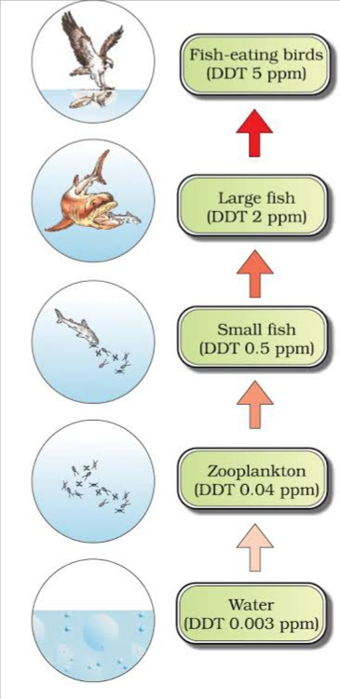

- What ecological term is used to describe DDT accumulation at different trophic level?
- List any one effect of DDT accumulation on birds.
- Will DDT accumulation lead to eutrophication?
- Does it affect the BOD?

- Biomagnification
(1)
- High concentration of DDT disturbs calcium metabolism in birds which causes thinning of egg shell and their premature breaking, eventually causing decline in bird population.
(1)
- No.
(0.5)
- No.
(0.5)

- Observe the diagram and answer the following.
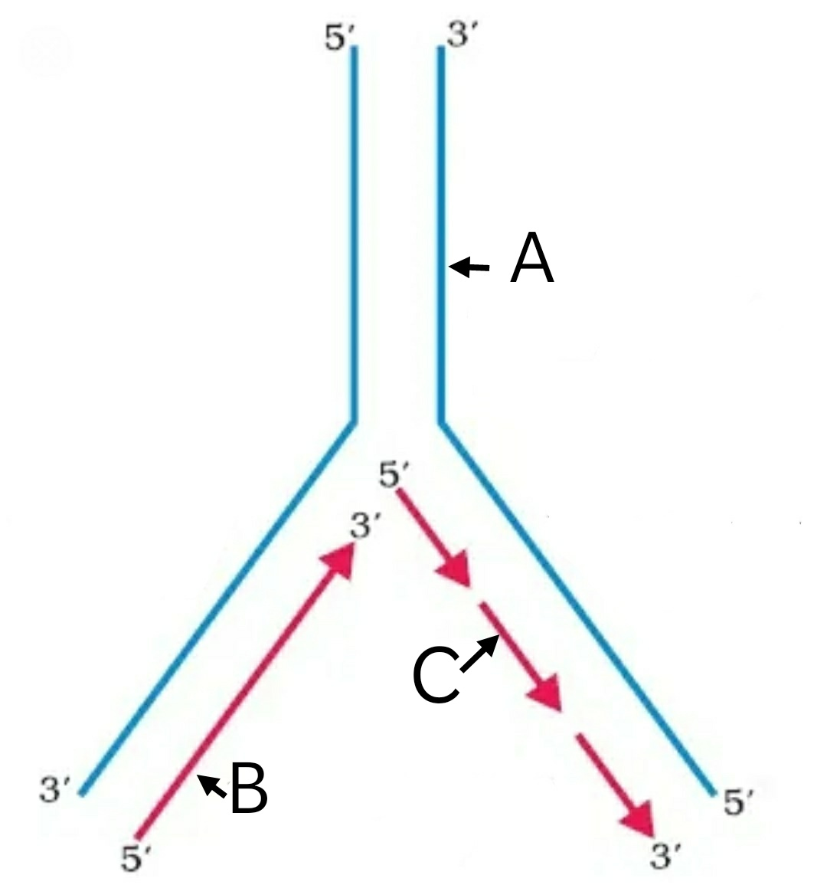
- What does the picture represent?
- Identify A, B & C
- Name any two enzymes needed for this process

- DNA replication/replication fork
- A: Template DNA/parental strand
B: Leading strand/continues synthesis
C: Okazaki fragments
- DNA polymerase; DNA ligase
(6 X 0.5 = 3)

- Analyze the graph and answer the questions based on it.

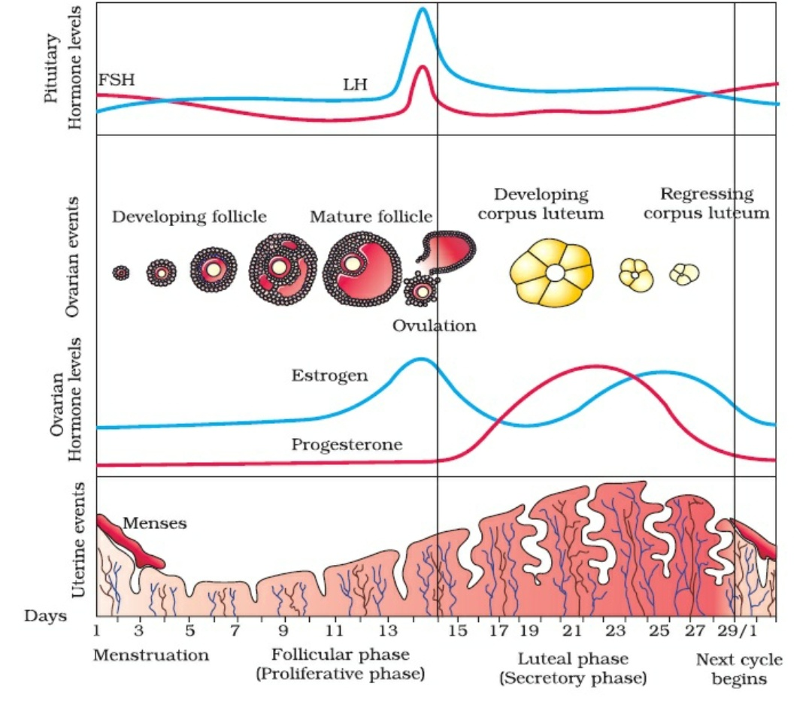
- When does the secretion of LH & FSH attain its peak level? What is the result of rapid secretion of LH?
- When does the level of Progesterone rise? Why it is essential?
- A proper understanding of menstrual cycle can help immensely in family planning. Do you agree with the statement? Provide reasons for your answer.

- On the 14th day of cycle
(0.5)
Rapid secretion of LH ruptures the Graafian Follicle and release ovum – ovulation
(0.5)
- On 19th – 23rd day
(0.5)
It rises from 16th of the cycle - Essential for maintenance of endometrium/pregnancy
(0.5)
- Yes; because ovulation occurs during mid cycle; chances of fertilization if very high. So, couples should abstain from coitus between days 10 – 17.
(1)
(3)

SECTION E

- A) Draw a diagram of an enlarged view of TS of one microsporangium of angiosperm and label the following parts
- Tapetum
- Middle layers
- Endothecium
- Microsporemothercells

B) Mention the characteristic features and function of tapetum.
C) Explain the following giving reasons.
i) Pollen grains are well preserved as fossils
ii) Pollen tablets are in use by people these days

- Refer NCERT, Page 23, Fig. 2.3 (b).
(1 mark for figure + 0.5 X 4 = 2 for labelling)
- Tapetum – innermost layer - dense cytoplasm - generally have more than one nucleus.
(0.5)
Function: It nourishes the developing pollen grains.
(0.5)
- i. Exine made of sporopollenin – resistant to enzyme of organisms – withstand high temperature and strong acids.
(1)
ii. Pollen grains are rich in nutrients. Pollen tablets are taken as food supplements. They increase the performance of athletes and race horses.
(1)

OR
Read the statement and answer the questions that follows
“A flower of tobacco has 120 ovules in its ovary. However, it produces a fruit with only 100
viable seeds”
- What could have prevented the rest 20 ovules from maturing into viable seeds? Explain giving reasons.
- Briefly describe the development of dicot embryo in a viable seed.
- Why certain angiospemic seeds are albuminous while others are ex-albuminous. Explain.

- The 20 pollen grains may be of wrong type. The pistil rejects the pollen by preventing pollen germination on the stigma. The rejection is the result of continuous dialogue between pollen grain and pistil / Self-incompatibility
(1)
- Zygote gives to pro-embryo
(0.5)
Globular
(0.5)
Heart-shaped
(0.5)
Mature Embryo parts: embryonal axis, cotyledons, plumule and radicle
(1.5)
- Ex-albuminous seeds have no residual endosperm as it has completely consumed during embryo development.
(0.5)
Albuminous seeds retain a part of endosperm as it is not completely used up during embryo development.
(0.5)
(5)

- a) How has the use of Agrobacterium tumifaciens as vector helped in controlling Meloidegyne
incognitia infestation in tobacco plants? Explain in correct sequence.

b) Describe the responsibility of GEAC, set up by Indian Government.

- How is ‘Rosie’ considered different from a normal cow.

- Using Agrobacterium vector nematode specific genes introduced into host plant.
- Sense and antisense strands of mRNA are produced.
- ds RNA is formed.
- ds RNA initiates RNAi.
- Prevents translation of mRNA/silencing of mRNA of parasite/nematode.
- Parasite will not survive.
(0.5 X 6 = 3)

- Making decisions regarding validity of GM research and safety of producing GM organisms for public services.
(1)
- The first transgenic cow, Rosie, produced human protein-enriched milk.
(1)
(3+1 + 1 = 5)

OR

- Explain briefly PCR Technique by diagrammatic representation.

- Why a patient of ADA deficiency requires repeated infusion of genetically engineered lymphocytes? Suggest a possible permanent remedy.

- Refer NCERT Textbook, Page 202, Fig. 11.6.
(3)
- The patient lacks functional T lymphocytes and fails to resist the infectious pathogen. With the help of gene therapy, the lymphocytes are extracted from the patient’s bone marrow and a normal functional gene for ADA is introduced into the lymphocytes using retro virus. The gene that has been isolated from bone marrow cells that produce ADA can be introduced in the cells at early embryonic stages. Further the growing embryo will never show the ADA deficiency.
(2)
(3+2 = 5)

- a) Following are the responses of different animals to various abiotic factors. Describe each one with the help of an example
- Regulate
- Conform
- Migrate
- Suspend

b) If 8 individuals in a population of 80 butterflies die in a week, calculate the death rate of population of butterflies during that period.

- Regulate: Maintain constant internal temperature/osmotic concentration/homeostasis
(0.5)
E.g., birds/mammals.
(0.5)
Conform: Do not maintain constant internal temperature/osmotic concentration/ no homeostasis
(0.5)
E.g., any one example of animal other than birds and mammals
(0.5)
Migrate: Temporary movement of organisms from the stressful habitats to hospitable areas and return when stressful period is over
(0.5)
E.g., birds from Siberia or any other correct examples
(0.5)
Suspend: Reducing the metabolic activity during unfavorable conditions
(0.5)
E.g., Polar Bear/amphibian/snails/any other correct example of animals
(0.5)

- Death Rate = 8/80 = 0.1 individuals per butterfly per week.
(0.5 + 0.5)
(4+1 = 5)

OR

- What is a trophic level in an ecosystem? What is ‘standing crop’ with reference to it?
- Explain the role of the ‘first trophic level’ in an ecosystem.
- How is the detritus food chain connected with the grazing food chain in a natural ecosystem?

- Specific place of an organism in a food chain, mass of living material (biomass) at each trophic level at a particular time.
(1+1)
- First trophic level has producers/autotrophs, which trap solar energy/to produce food (photosynthesis).
(1+1)
- Organisms of the Detritus Food Chain (DFC) are the prey to the Grazing Food Chain (GFC). The dead remains of GFC are decomposed into simple inorganic materials which are absorbed by DFC organisms
(0.5+0.5)
(2+2+1 = 5)

